DOCUMENTATION

Better Each Day

Sebastian Stăvar

Contents
1. Assignment Objective 2
2. Problem Analysis, Modeling, Use Cases 2
3. Design 3
4. Implementation 6
5. Conclusions 8
6. Bibliography 8

Assignment Objective
The implementation and development of an application that uses a system of quests, tokens and badges that provides users with a fun polynomial challenge. Based on how many tokens a user achieves, they will be placed in a ranking system and earn badges.
A list of main objectives used to implement this project are:
- “Sign in” and “Sign up” options.
- Creating and accomplishing a quest.
- A ranking system to display the players with the most quests completed.
- Visualizing your quests and becoming better each day.
A list of sub-objectives that are required to follow for achieving the main objective:
- Validating data for when signing up, creating, or completing a quest.
- A Graphical User Interface (GUI).
- A database to store all data.

Problem Analysis, Modeling, Use Cases
Being given a task that offers me freedom, I chose to build the quest system around polynomials and mathematical operations. To do that, I needed to implement at least the simple operations: add, subtract, multiply, and divide.
To keep my work organized and easier to access, I opted for a breakdown in directories: 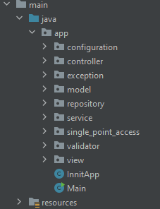
Use case:
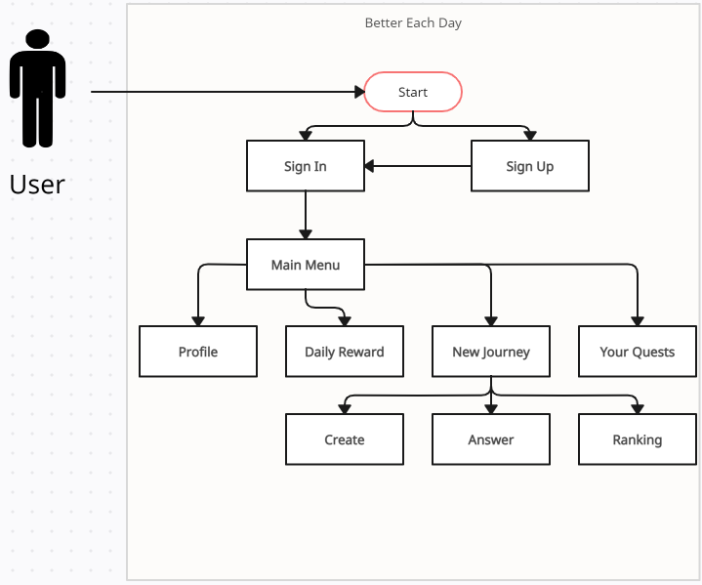

Design
UML package:
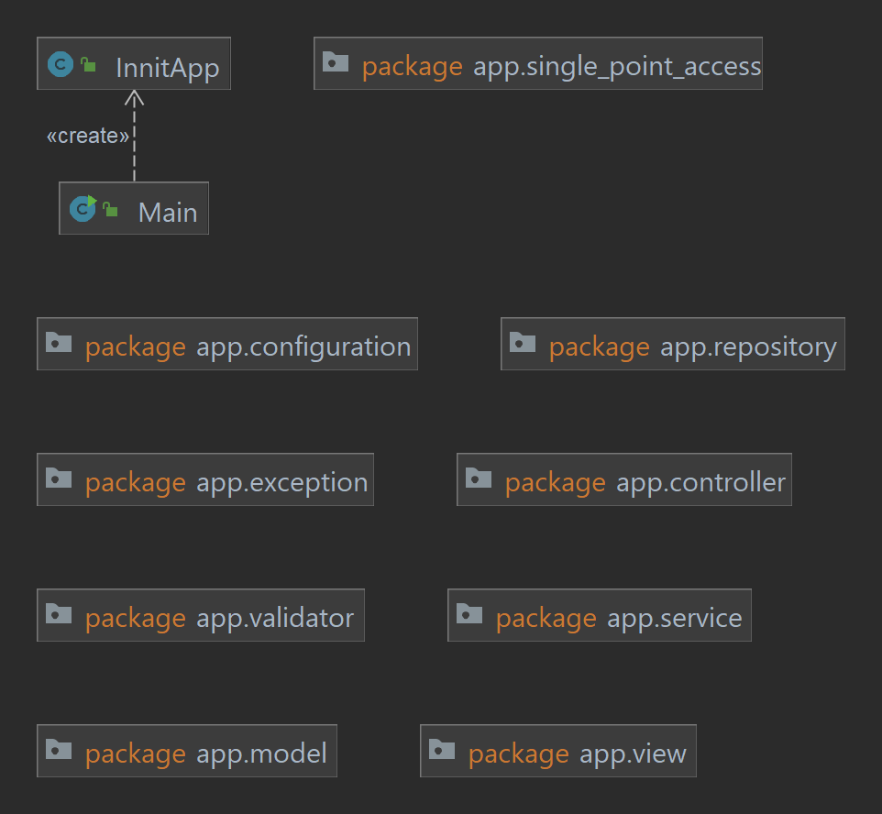

UML class diagram: 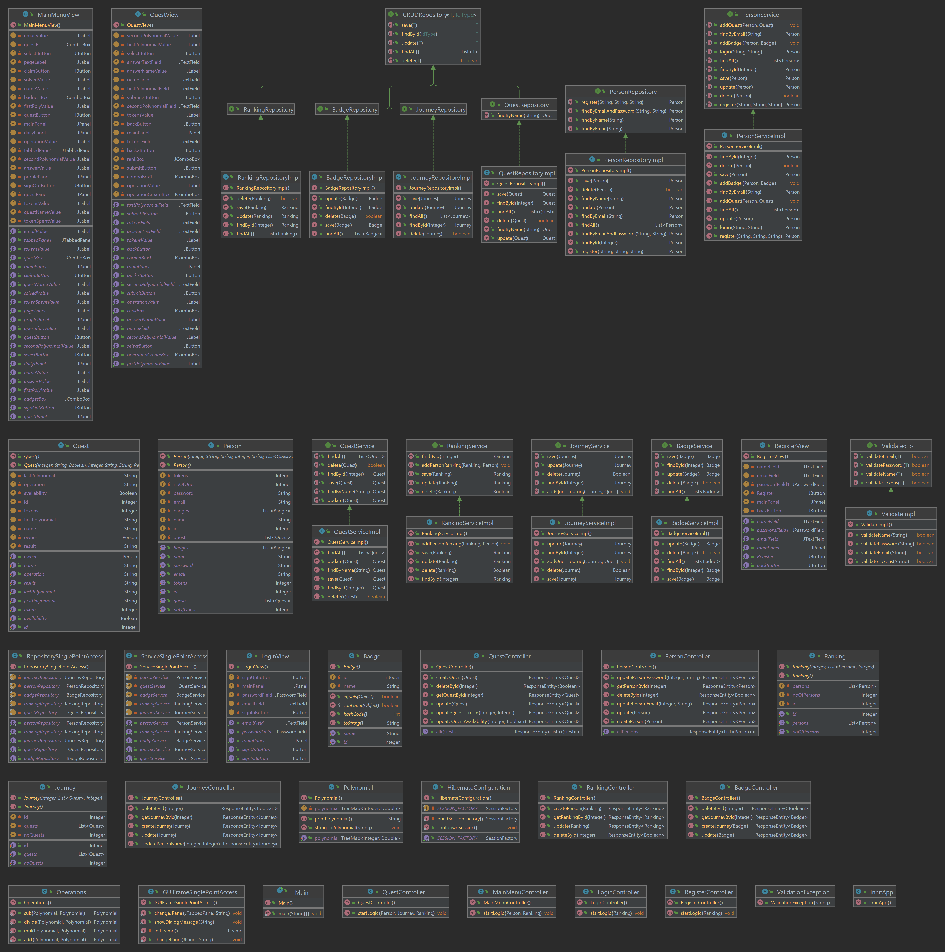
For the implemtation and use of the Polynomial class, I decided to use a TreeMap<Integer, Double>, Integer(the power of a monomial) and Double(the coefficient of a monomial). I chose this type of Map because it automaticly sorts the elements by the keys, and it allows a reverse navigation of them(used to display from the greatest key to the smallest one).
One algorithm used is for the division of two polynomials:
- Order the monomials of the two polynomials in descending order acording to their degree.
- Divide the polynomial with the highest degree to the other polynomial having the lower degree.
- Divide the first monomial of the first polynomial to the first monimial of the second polynomial and obtain the first term of the quotient.
- Multiply the quotient with the second polynomial and subtract the result of the multiplication from the first one, obtaining the remainder of the division.
- Repeat the procedure from step b. considering the remainder as the new divident of the division, until the degree of the remainder is lower than the
Graphical User Interface (GUI):
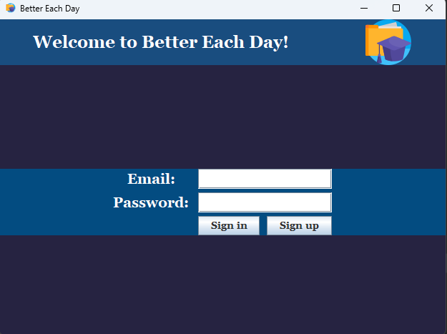
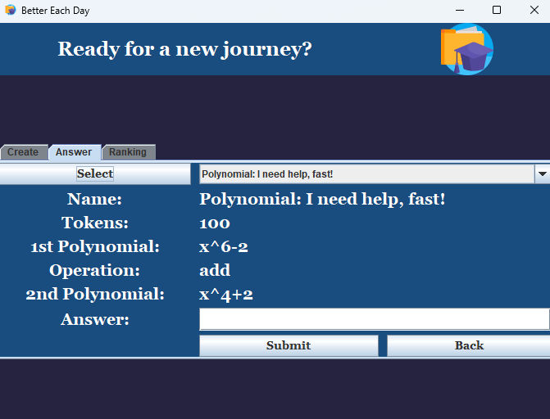

Implementation
Model: - a directory of which each class can be mapped to the database via hibernate.
- Person: - a class made to implement a user.
- as attributes, it has an id (Integer), name (String), password (String), tokens (Integer), email (String), quests (List<quest>), noOfQuest (Integer), badges (List<Badge>).
- Quest: - a class made to implement a quest.
- as attributes, it has an id (Integer), name (String), availability(Boolean), tokens(Integer), firstPolynomial(String), secondPolynomial(String), owner(Person), result(String), operation (String);
- Badge: - a class made to implement a badge.
- as attributes, it has an id (Integer) and a name (String).
- Journey: - a class made to keep all the quest packed.
- as attributes, it has an id (Integer), quests (List<Quest>) and noOfQuest (Integer).
- Ranking: - a class made to order the users.
- as attributes, it has an id (Integer), persons (List<Person>) and noOfPerson (Integer).
- Polynomial: - a class made to implement a polynomial.
- as attributes, it only has a TreeMap<Integer, Double>.
- as methods, it has printPolynomial(), that converts a polynomial to string so it can be easier to print and compare. And the second method is stringToPolynomial (String), that based on a regular expression converts a string to a polynomial.
- Operations: - a class made to implement the mathematical operations that are meant to be applied to polynomials.
- as methods, is has add (adds two polynomials), sub (subtracts two polynomials), mul (multiplies two polynomials) and divide (divides two polynomials).

Controller:
I. gui:
I. LoginController: - a controller to map MySQL to the GUI that allows the user to sign into his account.
II. RegisterController: - a controller to map MySQL to the GUI that allows the user to sign up an account to use this application.
III. MainMenuController: - a controller to map MySQL to the GUI that allows the user to view their details, to claim a daily reward, to view his quests and navigate to a new “journey.”
IV. QuestController: - a controller to map MySQL to the GUI that allows the user to create, accomplish a quest or new the global ranking of the users.
II. rest:
I. PersonController: - a class to control a person with the use of Postman.
II. QuestController: - a class to control a quest with the use of Postman.
III. BadgeController: - a class to control a badge with the use of Postman.
IV. JourneyController: - a class to control the journey with the use of Postman.
V. RankingController: - a class to control the ranking with the use of Postman.

Repository: - a directory of interfaces that implements CRUD methods such as: save, update, delete findById and findAll.
- each interface has its own class that implements each method for each class (Person, Quest, etc.).

Service: - a directory of interfaces, like Repository, but implements methods that are more advanced, such as adding an object to a list of objects.
- each interface has its own class that implements each method for each class (Person, Quest, etc.).

Single_Point_Access: - a directory of which each class is used to avoid repetition and keep everything packed and easier to access.
- GUIFrameSinglePointAccess: - a class used to initiate every GUI panel used with a set of instructions.
- RepositorySinglePointAccess: - a class used to keep packed every repository.
- ServiceSinglePointAccess: - a class used to keep every service.

Validator: - a directory that consists of an interface and a class.
- Validate: - an interface.
- ValidateImpl: - the class that implements every method declared in the Validate interface.
- validateEmail: - the email needs to be smth@yahoo|gmail|proton.com.
- validatePassword: - the password needs to be at least six letters long, have one digit and one upper character.
- validateTokens: - the sum of tokens needs to be between [100, 999].
- validateName: - the name of the user needs to contain only letters.

View: - a directory that consists of Swing UI Designer GUI forms (a class and a form).
- LoginView: - for the sign in GUI.
- RegisterView: - for the sign-up GUI.
- QuestView: - for the creation and accomplishment of a quest, and the viewing of the global ranking.
- MainMenuView: - for the viewing of the user’s profile and quests that they created, to claim your daily reward or start a new journey (go to the guest section).

InnitApp: - a class used to initiate the application, which creates a user, two quests, the ranking, and the quest list.

Conclusions
This application taught me a lot more about myself and how to improve, hence I came up with the name of “Better Each Day”. This title motivated me when I felt a bit overwhelmed with all the ideas I wanted to implement in this brief period of time. I became more familiar with Hibernate and started learning Postman to migrate this application to frontend.
In the future, I would like to improve this application by allowing it to understand difficult polynomials and even other types of mathematical equations and problems. After all that, I would like to extend it with the help of others to be able to solve even other subjects such as programming, physics, chemistry, and general knowledge. My plan is to deploy this application to be used by all students and highschoolers and grow a community of thriving individuals.

Bibliography
- Bruce Eckel, Thinking in Java (4th Edition), Publisher: Prentice Hall PTRUpper Saddle River, NJUnited States, ISBN:978-0-13-187248-6 Published:01 December 2005.
- Polynomials: https://www.cuemath.com/algebra/division-algorithm-for-polynomials/

